Christmas Concert and End of Term 2022

As the excitement is rising fast, here are a few need to knows.
School uniform (Thursday and Friday) as usual please, as we need to keep as ‘normal’ as possible with all of the excitement.
Children can wear what they want when they come back at 6pm on Friday. It is always better if they bring a bag with them to make it easier to look after their own clothes.

Thursday 15th December
- The children will be performing at 1:15pm and will change back into their uniforms at the end of the day.
- Class 1 will perform first, followed by a short break for changing over props, then classes 2 & 3 will perform.
- 1:15 – 3:15pm is a rough idea of timings with the children then ready as usual at 3:30pm. Class 1 play has been about 30mins in rehearsals and the classes 2 & 3 play about 1 hour.

Friday 16th December
- The children will be performing at 6:30pm and will need to arrive at school (their classroom) at 6pm to get ready. Please bring your child around to their classroom.
- Class 1 will perform first, followed by a short break for changing over props, then classes 2 & 3 will perform.
- 6:30 – 8:30pm is a rough idea of timings with the children. Class 1 play has been about 30mins in rehearsals and the classes 2 & 3 play about 1 hour.
- The children will go back into the school to change at the end of the performances. At the end of the second play they will wait with us in classes 1 & 2 for you to collect them, so please come through the link into the school.
Monday 19th December
- You are invited to join us at 3pm on the school yard (or hall if the weather is bad) for carols with the children. This will replace the Christingle previously advertised.
Tuesday 20th December
- Christmas party – (Non-uniform) own clothes and / or Christmas jumpers
- Governors kindly provide party food for each child, in the afternoon in the hall
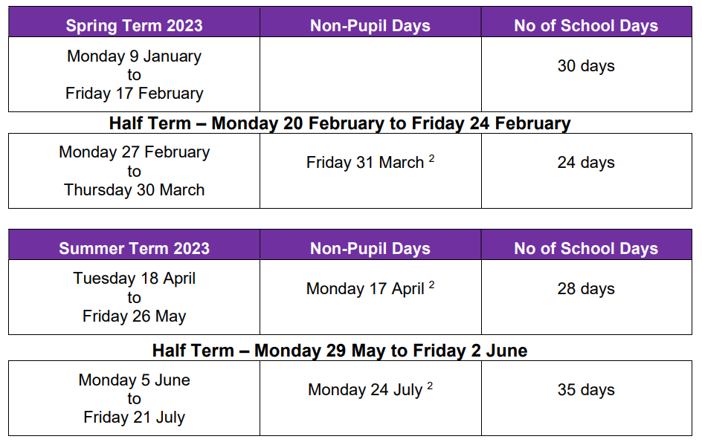
Wednesday 21st December
- Normal school day
- The children will be having a FREE treat together, watching a film show.

Any questions – Please email, telephone or just ask us.

