Ysgol Meifod
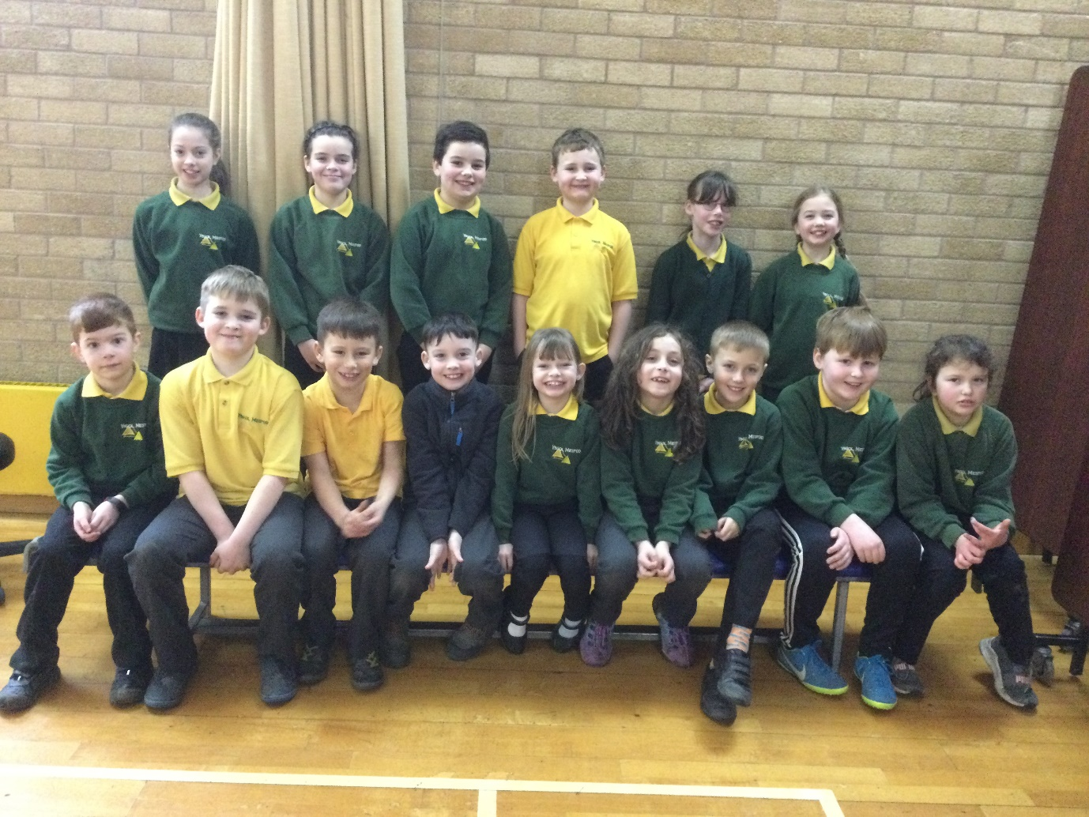
Singing Group

