Ysgol Meifod
Easter Raffle
If you would like to buy a ticket to win one of two hampers (like photos below)
Contact Hayley on 07966 697807, facebook messenger or ask any parent of Ysgol Meifod
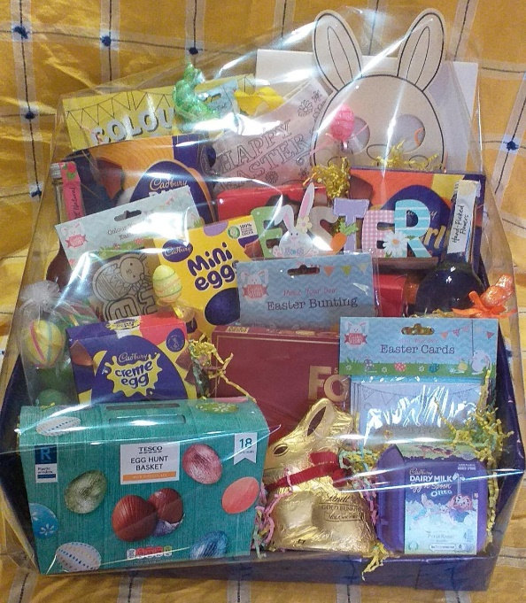
Tickets £5 each

Draw to take place Wednesday 29th March 2023

