the artist: John pearson-phillips.  John has lived in Meifod for four years, and before that spent a career teaching in state and private schools in and around London, ending his time as an assistant head-teacher. Now, he paints and draws all of the time and spends his days in the garden studio, or out and about with his portable easel. He prefers to work from first hand as this is challenging. Work includes portraits, local architecture, farm buildings and animals. He prefers to work in oils but is very happy to be confronted with a blank sheet of cartridge paper whilst holding a 2B pencil, or graphite stick. He has been commissioned a lot since being here and much of this work is on his Instagram page: jppart17.  Should you wish to commission him, his contact details are as follows:  22 Cae Robert, Meifod, SY22 6DY.  Johnpearsonphillips@btinternet.com  01938 500500 and 07947 943 320.  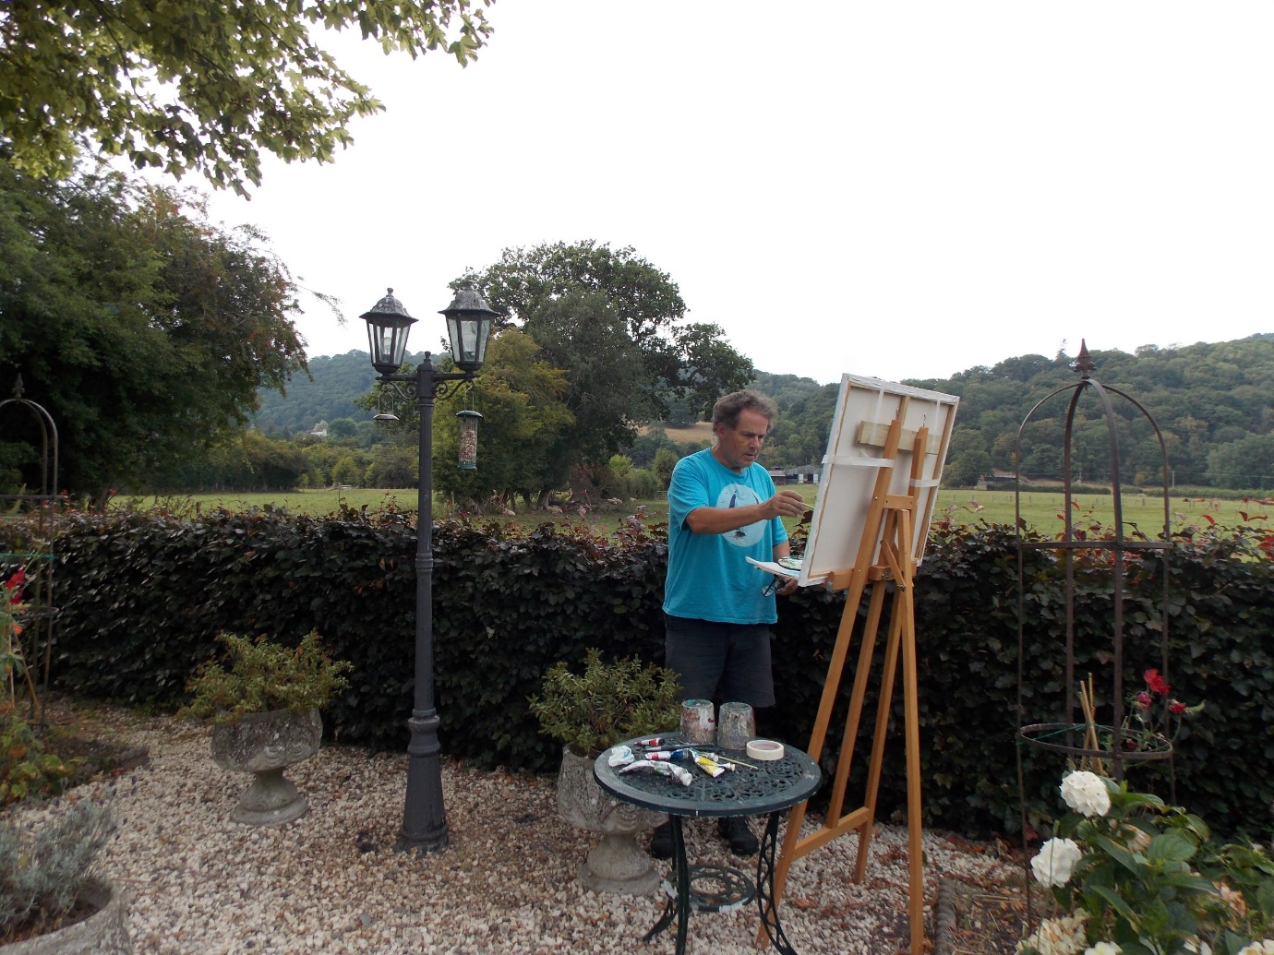 | 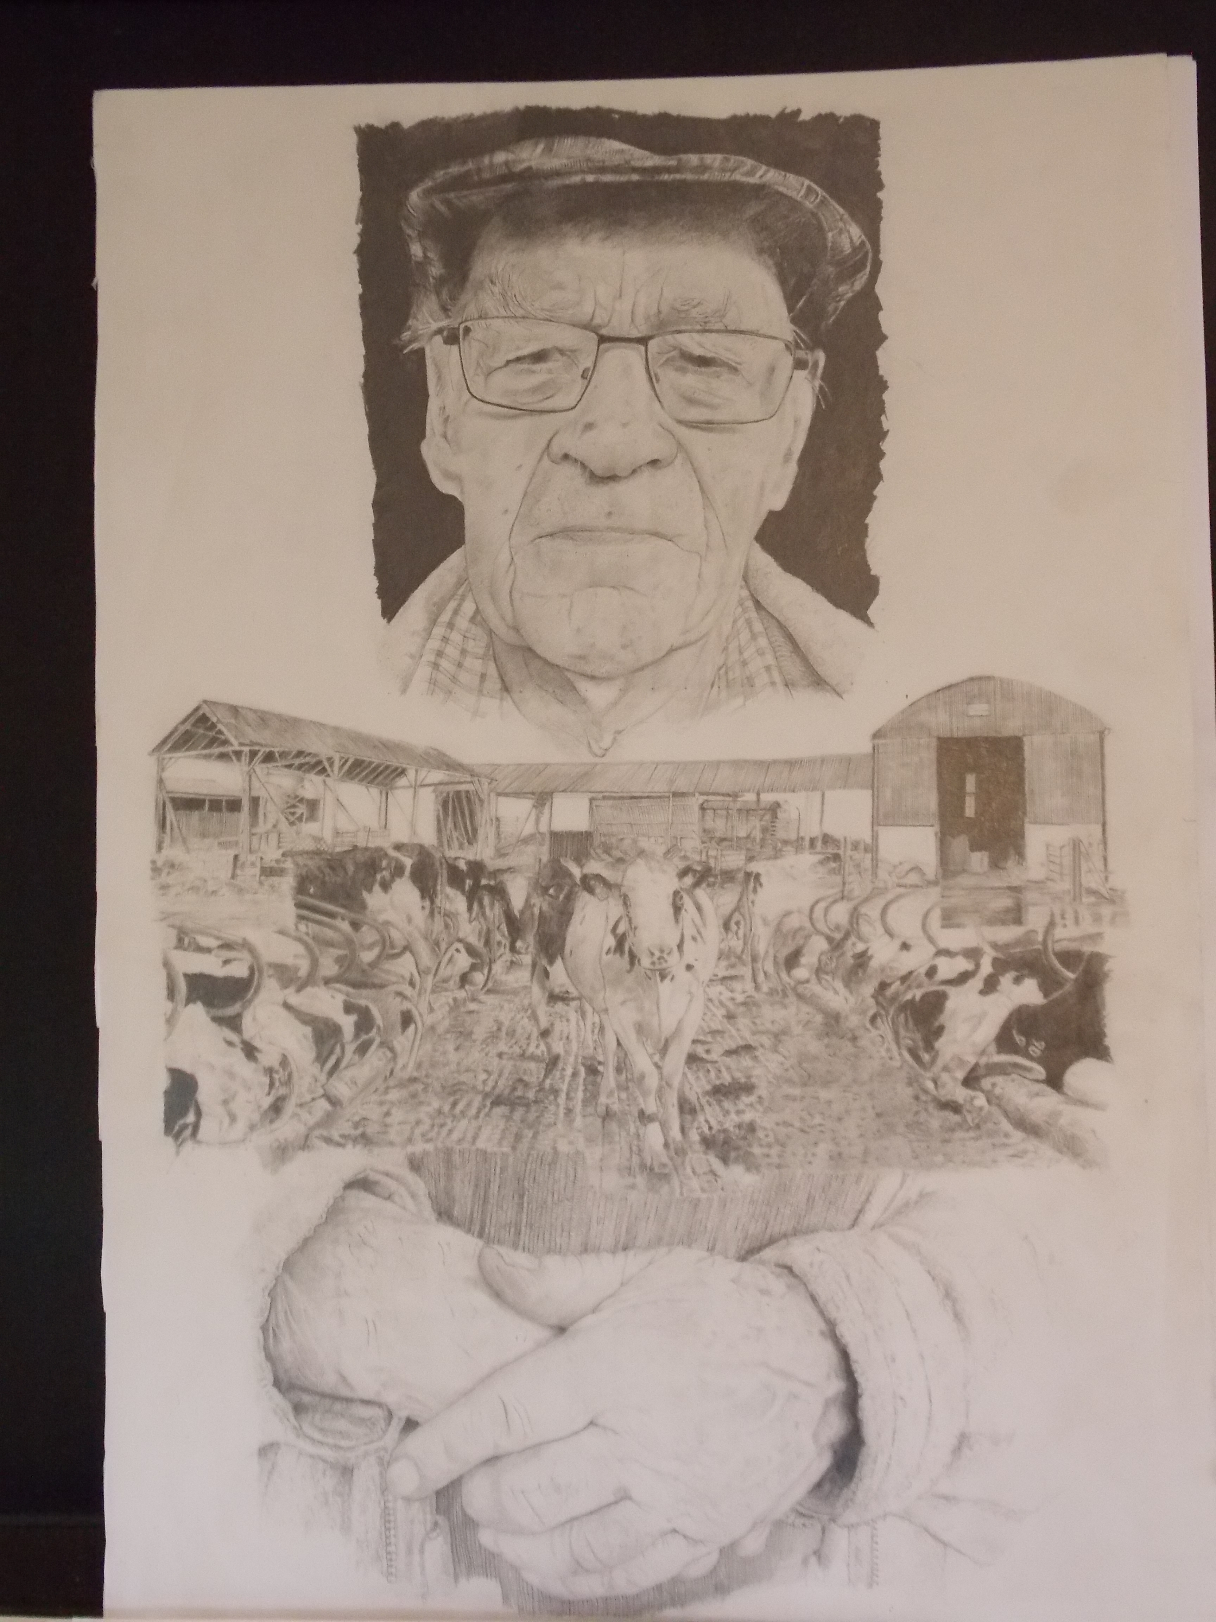  Glyn Owen.  The idea.  The exhibition contains numerous portraits of people who live in and around Meifod, and if you have lived here a while you will recognize someone I am sure. The idea for a body of work such as this, that I have entitled ‘Landscape of the Face,’ first came to me when I saw Glyn Owen outside the post office: I just had to draw him! His facial characteristics were so compelling (I especially liked drawing his hands however). I discovered he’d lived here all his life and had worked on Jonathan Wilkinson’s farm during that time. From this, an idea germinated, hence this exhibition. I have also added a few paintings of seascapes to provide variety: these are for sale, the portraits will be given to the ‘sitters.’ I hope to do another exhibition next year at around the same time and will invite those whose faces we see now to show their portraits again; so we get a bigger picture of our local community in 2026. | ART EXHIBITION.  ‘Landscape of the Face,’  by John Pearson-Phillips.  October 4th and 5th  Meifod Village Hall.  10 – 2pm.  (voluntary Entrance fee for adults: £1. All MONIES GO TO THE TINY TOTS PLAYGROUP HERE IN MEIFOD).  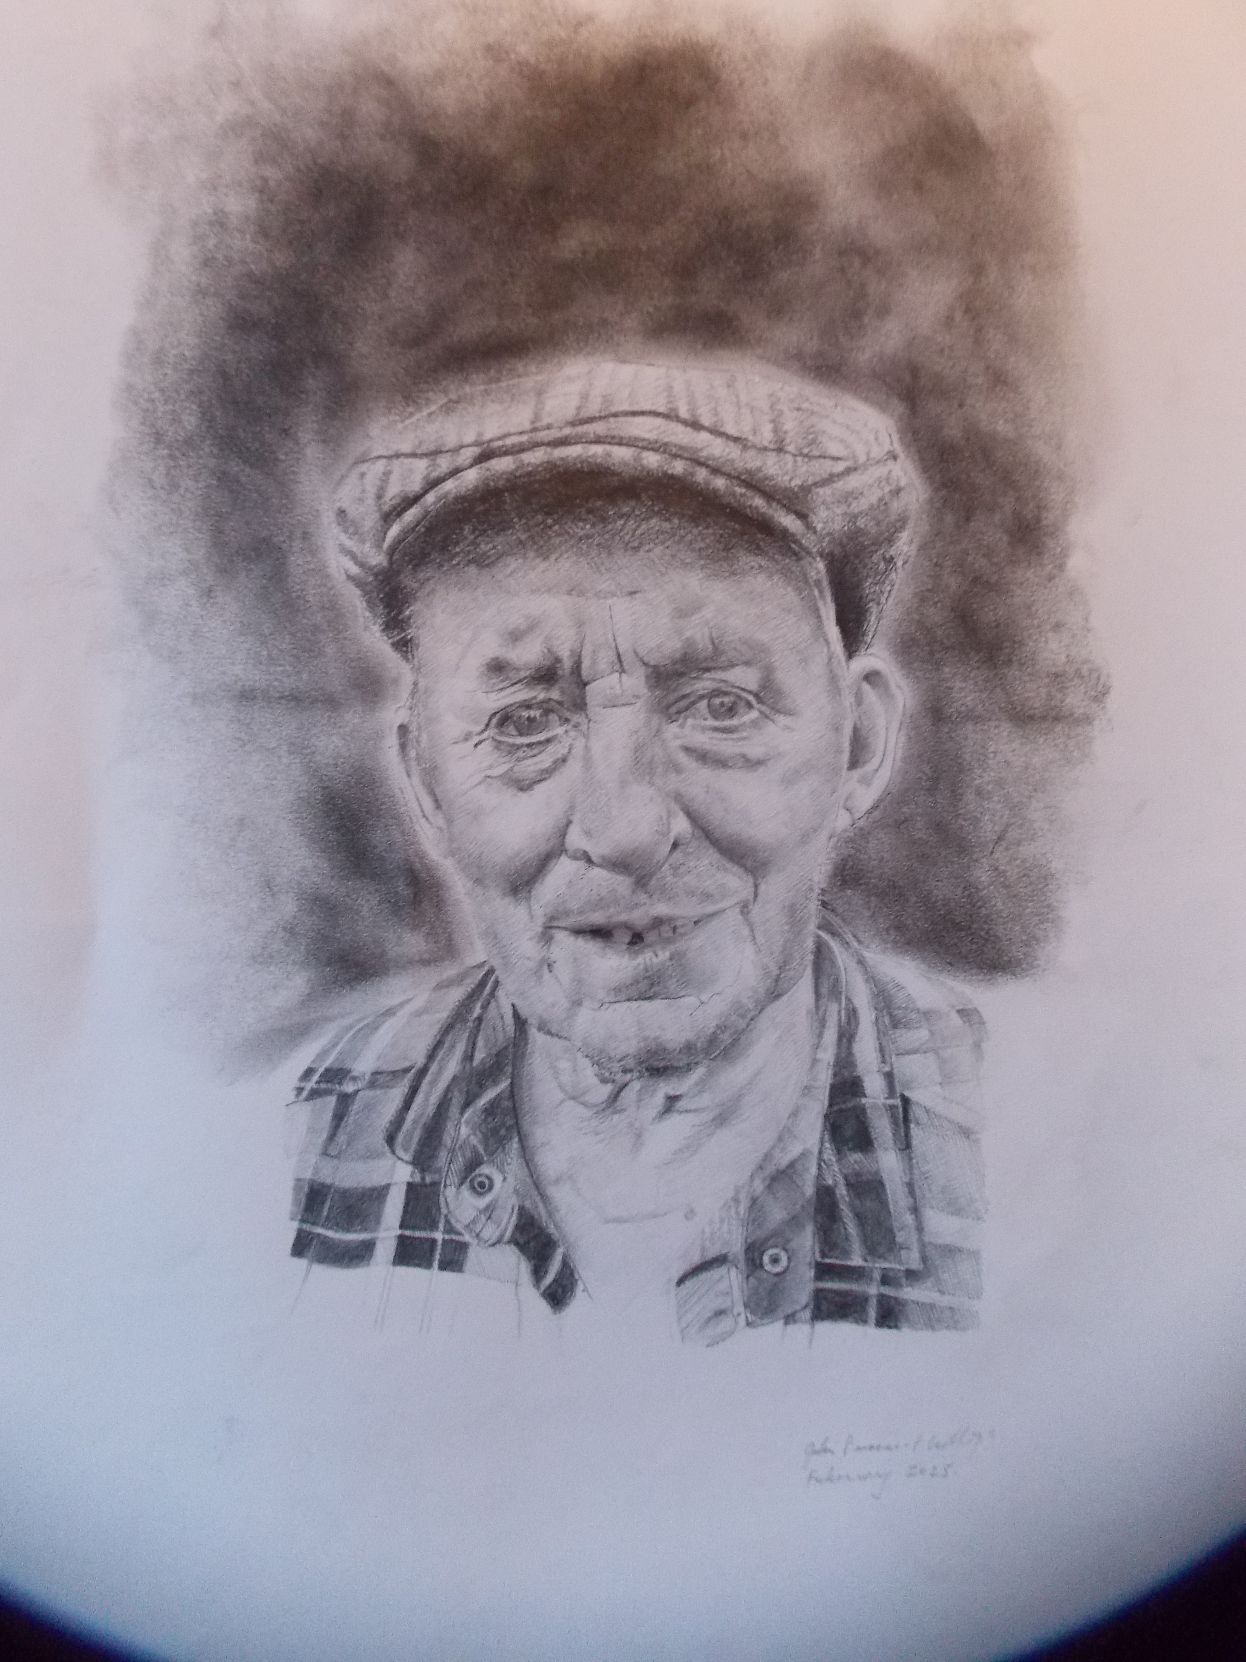  Adrian Williams.
Some more work….  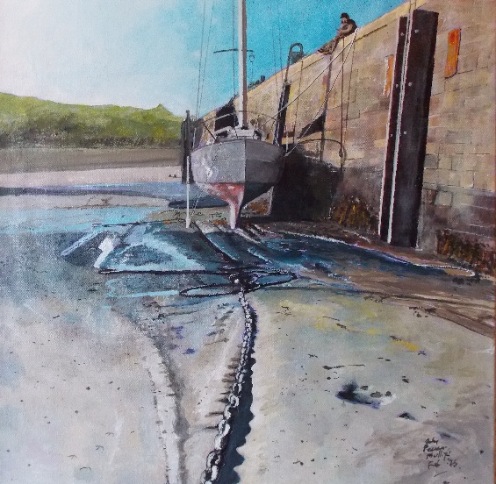  Tenby harbour.  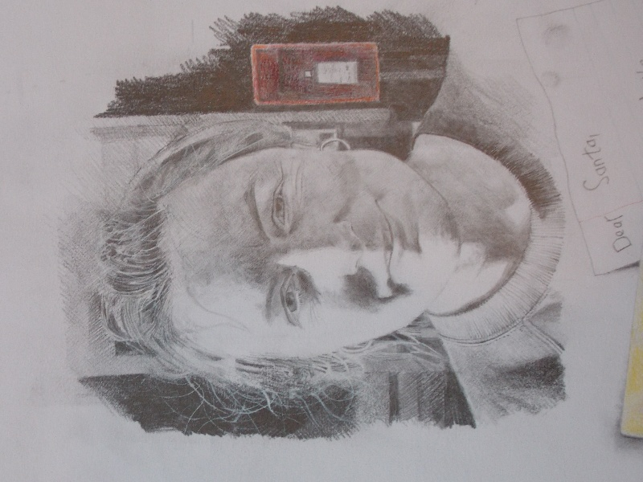  Mari Lewis. | 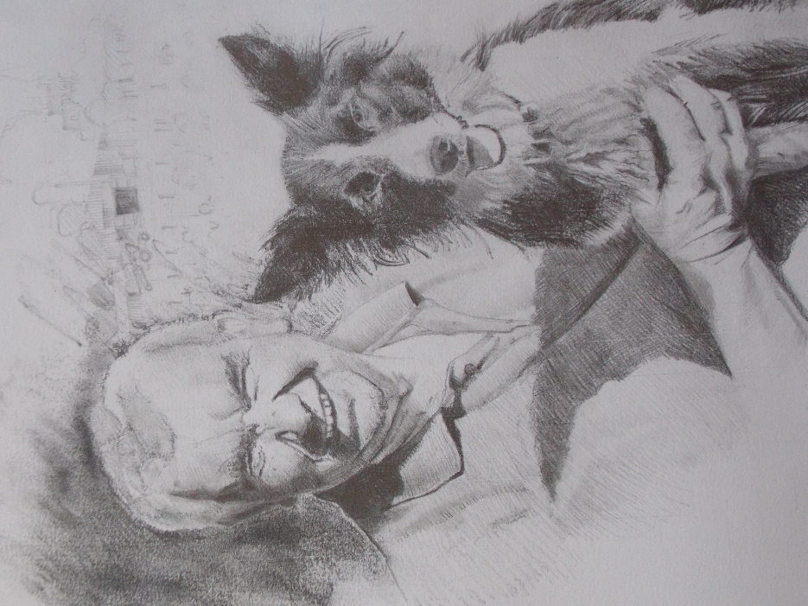  Phil Watkin and Mags.  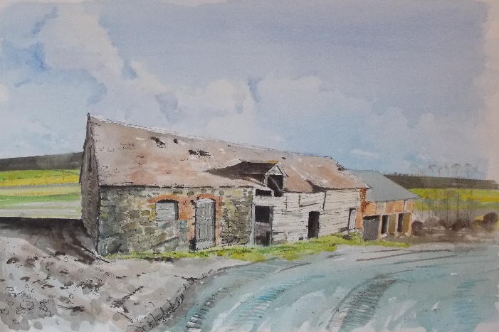  Barn Allt Fawr, Meifod. | 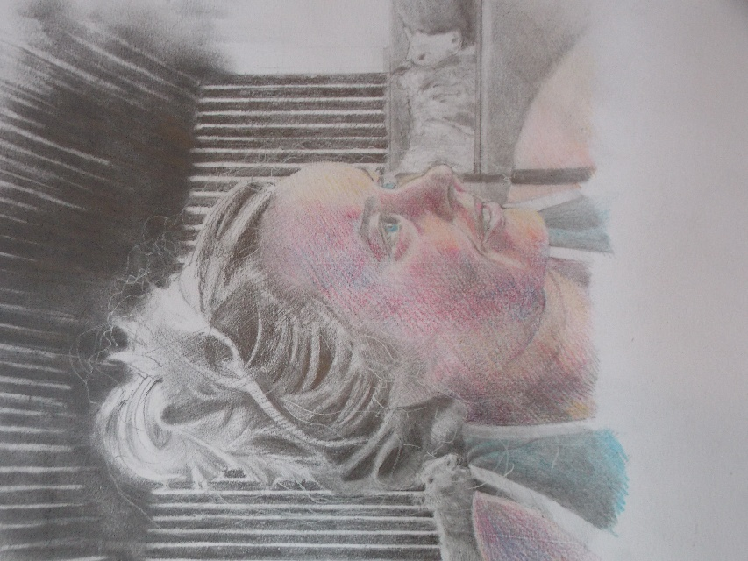  Sarah.  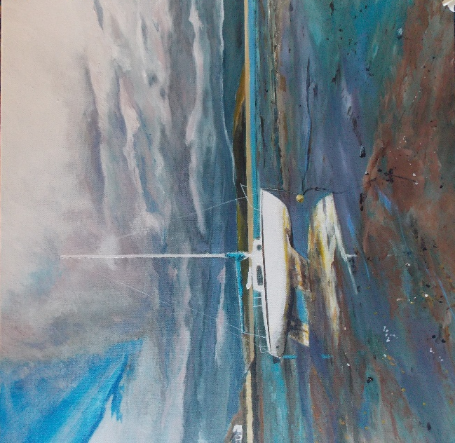  Borth y Gest.
 | Heading 7  Heading 2  Heading 9  Heading 4  Heading 5  Heading 6  Heading 4  Heading 5  Heading 6  Heading 4  Heading 5  Heading 6  Heading 4  Heading 5  Heading 6  Heading 4  Heading 5  Heading 6  Heading 4  Heading 5  Heading 6  Heading 4  Heading 5  Heading 6  Heading 4  Heading 5  Heading 6 | Heading 7  Heading 2  Heading 9  Heading 4  Heading 5  Heading 6  Heading 4  Heading 5  Heading 6  Heading 4  Heading 5  Heading 6  Heading 4  Heading 5  Heading 6  Heading 4  Heading 5  Heading 6  Heading 4  Heading 5  Heading 6  Heading 4  Heading 5  Heading 6  Heading 4  Heading 5  Heading 6
Use styles to easily format your Word documents in no time. | On the Home tab of the ribbon, check out Styles | Find even more easy-to-use tools on the Insert tab
Telephone | Street Address, City, ST ZIP Code | Website

